**Experiment no. 6**

**Name: Sonali Dattatray Kaingade**

**PRN: 21620002**

**Title:** Find 5 no. summary of a dataset.

**Code:**

#include <iostream>

#include <fstream>

#include <sstream>

#include <vector>

#include <algorithm>

using namespace std;

// Function to calculate the median of a vector

float calculateMedian(vector<int> a)

{

    int size = a.size();

    if (size % 2 == 1)

        return a[size / 2];

    else

        return (a[(size / 2) - 1] + a[size / 2]) / 2.0;

}

// Function to calculate the first quartile (Q1)

float calculateQuartile1(vector<int> v)

{

    int n = v.size();

    vector<int> first;

    for (int i = 0; i < n / 2; i++)

    {

        first.push_back(v[i]);

    }

    return calculateMedian(first);

}

// Function to calculate the third quartile (Q3)

float calculateQuartile3(vector<int> v)

{

    int n = v.size();

    vector<int> last;

    if (n % 2 == 0)

    {

        for (int i = n / 2; i < n; i++)

        {

            last.push_back(v[i]);

        }

    }

    else

    {

        for (int i = n / 2 + 1; i < n; i++)

        {

            last.push_back(v[i]);

        }

    }

    return calculateMedian(last);

}

int main()

{

    ifstream in("five_number_input.csv");

    if (!in.is_open())

    {

        cout << "Error: Unable to open the input file." << endl;

        exit(0);

    }

    ofstream out("five_number_output.csv");

    int i = 0;

    string line, mark;

    vector<int> arr;

    // Read data from the input file

    while (getline(in, line))

    {

        if (i == 0)

        {

            i++;

            continue;

        }

        stringstream str(line);

        getline(str, mark, ',');

        int x = stoi(mark);

        arr.push_back(x);

    }

    int n = arr.size();

    sort(arr.begin(), arr.end());

    // Write results to the output file and console

    out << "Minimum value: "

        << "," << arr[0] << "\n";

    out << "First Quartile (Q1) value: "

        << "," << calculateQuartile1(arr) << "\n";

    out << "Median value: "

        << "," << calculateMedian(arr) << "\n";

    out << "Third Quartile (Q3) value: "

        << "," << calculateQuartile3(arr) << "\n";

    out << "Maximum value: "

        << "," << arr[n - 1] << "\n";

    cout << "The minimum value is " << arr[0] << endl;

    cout << "The First Quartile (Q1) is " << calculateQuartile1(arr) << endl;

    cout << "The median is " << calculateMedian(arr) << endl;

    cout << "The Third Quartile (Q3) is " << calculateQuartile3(arr) << endl;

    cout << "The maximum value is " << arr[n - 1] << endl;

    return 0;

}

**Result:**

**Input:**

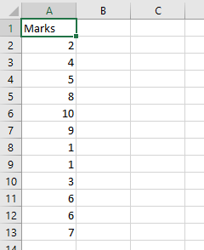

**Output:**

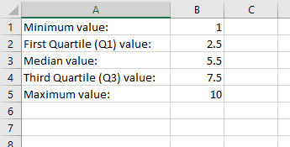

knime:

